Skill - 2

Task - 1:
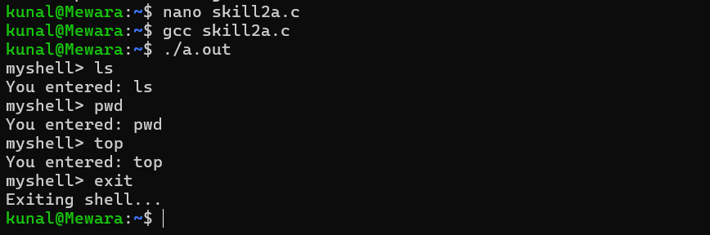

Task – 2:

